Name : Muhammad Haseeb Lab Task:1 Class : BSAI(3A)
Answer 01).
Year/Period | AI Milestone | Significance | Source
1956 | Dartmouth Conference | The Dartmouth workshop helped establish AI as a formal field of research. | Dartmouth College
1966 | ELIZA | ELIZA demonstrated an early form of computer-based natural-language conversation. | MIT
1974–1980 | First AI Winter | Reduced funding and disappointment with AI progress led to a significant decline in AI research activity. | Academic sources
1997 | IBM Deep Blue defeats Kasparov | Deep Blue's victory demonstrated that computers could achieve superhuman performance in a major intellectual game. | IBM
2012 | AlexNet / GPU-powered deep learning | AlexNet's success showed the major impact of large datasets and GPU computing on modern deep learning. | NeurIPS/ImageNet
2017 | Transformer architecture | The Transformer introduced a highly scalable architecture that became foundational to modern language models. | Google Research

Answer 03). Conversational Test vs. General Intelligence
A conversational test, such as the Turing Test proposed by Alan Turing in 1950, mainly observes whether a machine can produce responses that are difficult to distinguish from those of a human in conversation. In the scholarship case, a conversational AI might answer questions about eligibility, explain scholarship rules, and communicate fluently with a student. This shows conversational ability, but it does not by itself prove that the system has general intelligence.
The test does not establish that the AI can reliably perform different types of tasks, reason correctly in unfamiliar situations, verify its own answers, or consistently make accurate decisions. A system could produce a confident and fluent explanation while still making an incorrect logical conclusion. For example, an AI might say, “The student scored 70, so the student automatically qualifies for the scholarship,” while ignoring another required condition such as document completeness or attendance. The response sounds reasonable, but the reasoning is incorrect because the scholarship decision depends on multiple conditions.
Therefore, conversational fluency should not be treated as proof of general intelligence. A stronger additional test would be reliable task-performance testing: give the AI several unseen scholarship cases and require it to apply all rules correctly, provide the correct PASS/FAIL result, and explain the reason. Its performance should then be checked against the known correct answers across multiple cases.
Historically, Turing's 1950 paper proposed the imitation game as a way of discussing machine intelligence, but it did not establish a complete definition or measurement of general intelligence. Later AI research has used broader evaluations involving reasoning and task performance rather than conversation alone.
Sources:
- Turing, A. M. (1950), Computing Machinery and Intelligence, Mind, 59(236), 433–460.
- Stanford Encyclopedia of Philosophy, “The Turing Test.”
Answer 03). 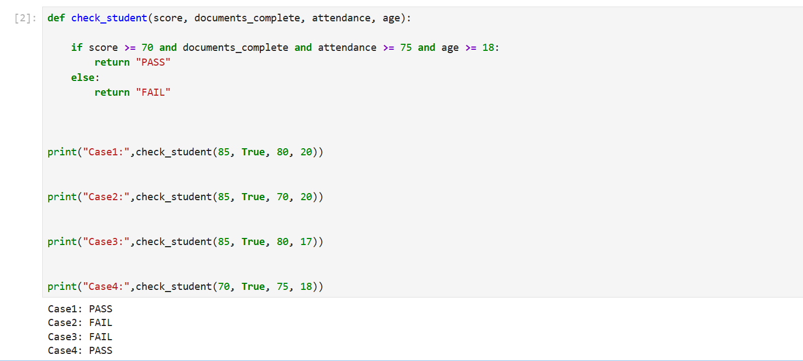
How to work this program ? This program only print casewise pass or fail we take test four cases score , documents , attendance , age if all cases are fulfill then output is pass and if any one is not fulfill then output is fail .
Case 1 — PASS
Score = 85, documents complete, attendance = 80%, age = 20. All four rules are satisfied.
Case 2 — FAIL
Attendance is 70%, which is below the required 75%.
Case 3 — FAIL
Age is 17, which is below the required 18 years.
Case 4 — PASS
Score = 70, attendance = 75%, age = 18, and documents are complete.

